TG Clean ApS Tel: + 46 43908400
Email: tg@tg-clean.dk Web: www.tg-clean.dk

Technical Datasheet

Name: TG Grafitti Wipes

Produce Code: B81040012

Characteristics:
Aspect: impregnated wet wipe
Colour: white
Odour: characteristic odour, alcohol

Characteristics of non-woven:
Non-woven: white polypropylene viscose non-woven, 32gsm
Dimensions: 280 x 280mm +/- 10%, 150 wipes per 3L bucket

Composition:
Impregnation formula: Citrus terpenes

Applications:
Pre-impregnated wipes designed for removal of paint and graffiti from flat non-porous surfaces

Features:
A pre-impregnated alcohol based cleaning solution delivers a measured dose to surfaces. Eliminates mixing errors – easy and convenient to use, reduces wastage and improves cost efficiency. Easily portable. Substrate offers strength and excellent mechanical cleaning action.

Method of use:
Remove lid by first use. Take first wipe from centre of roll and feed through lid aperture.
Replace lid. Remove one wipe, close lid and apply wipe to surface.
Dispose of wipe correctly after use.

Precautions of use:
Close lid after removal of wipe
Wear suitable gloves and eye protection
Avoid contact with eyes and skin. In case of contact with eyes, rinse immediately with plenty of water and seek medical advice.
Keep away from sources of ignition

Packaging:
3L bucket containing 150 wipes
Outer carton: 4 buckets
Pallet: 50 cartons

Product image:
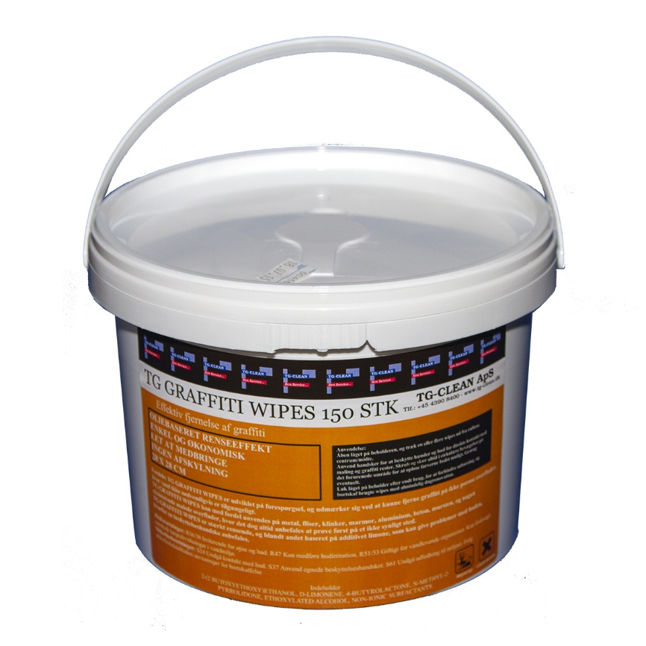

Options:
Wall-mounted bracket available separately.

